Part 1:

Encapsulation is used within my Horse class to restrict access to some of the object’s data, it being methods or attributes. This ensures that data is safeguarded and isn’t interreacted with unintentionally.

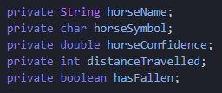

These attributes have been declared as private meaning they cannot be accessed from outside the class.

I then created the functionality of the getter functions/ accessor methods:

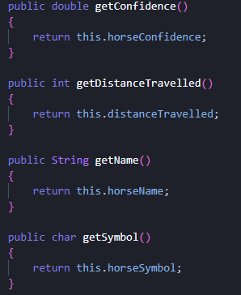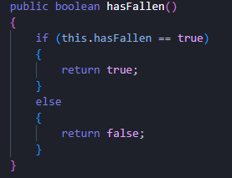

I also created the functionality for the setter functions/ mutator methods:

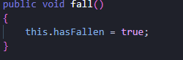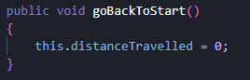

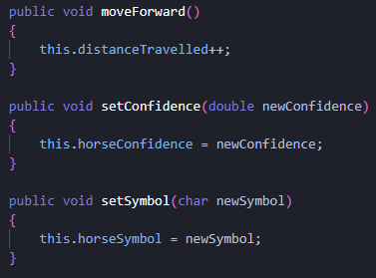

Part 1 tests:

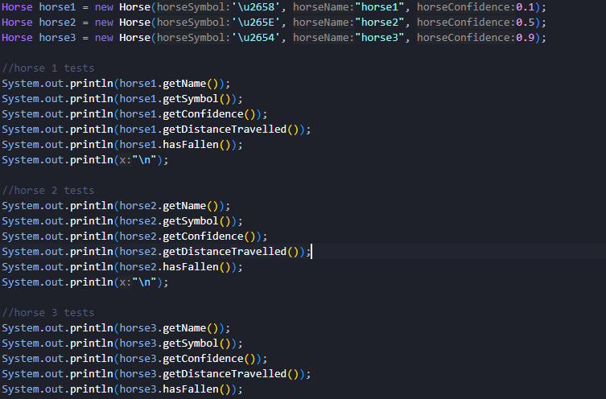

I created a new java file to test the attributes and methods I had created.

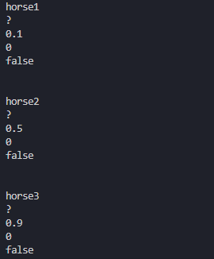

I created a test for 3 horses, a lower, mid and higher bound for the confidence. This tested the constructor I created, and the getter methods. I noticed the symbols were appearing as “?”, but this was due to my coding platform not having the UTF-8 encoding.

I then created a new horse to test the setters.

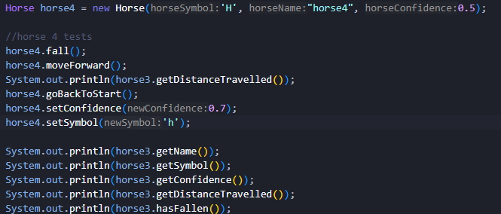

These were the results:

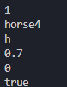

The 1 represents the move forward method which should move the horse forward by one. It then displays the new symbol as ‘h’ instead of what it was originally set as, ‘H’. Furthermore, it also displays the new confidence which was originally set is 0.5, but is now 0.7. The 0 printed suggests the goBackToStart method correctly works, as distance was 1 at the beginning of the block. Finally, in comparison to horse 1-3, it states true meaning fall() returns true once called.

I wanted to test further, the bounds of confidence as confidence should only be “represented as a decimal number between 0 and 1” as stated.





This displays that it correctly follows the rules of this class.

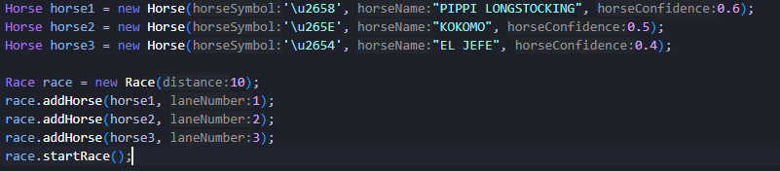

Firstly, I completed startRace by finding the winner of the race using an if statement after the race was finished. I then printed the winner and adjusted their confidence accordingly.

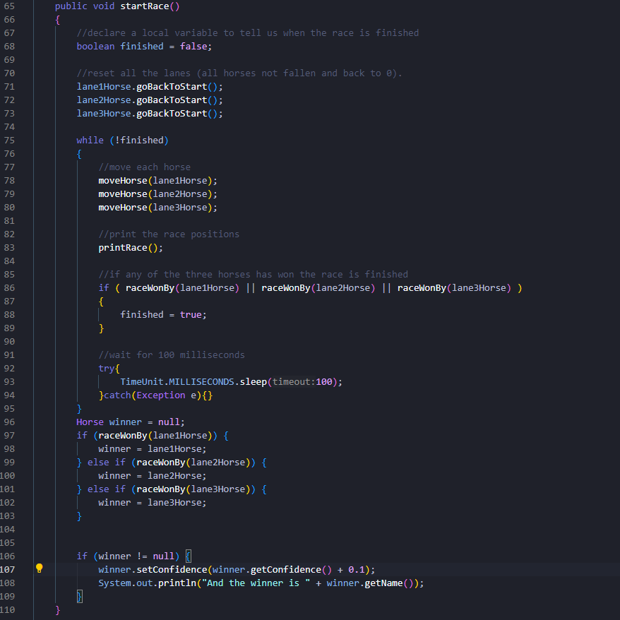

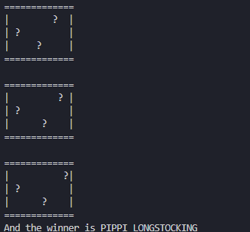

I noticed that adding 0.1 would sometimes cause the issue of a longer decimal, not rounded.

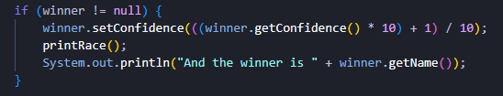

I then edited the Horse class as the horse would not lose confidence for a fall.

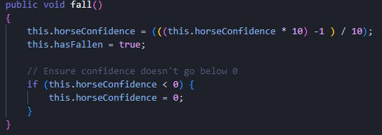

I then created a way for each confidence to be displayed so I could test if this worked.

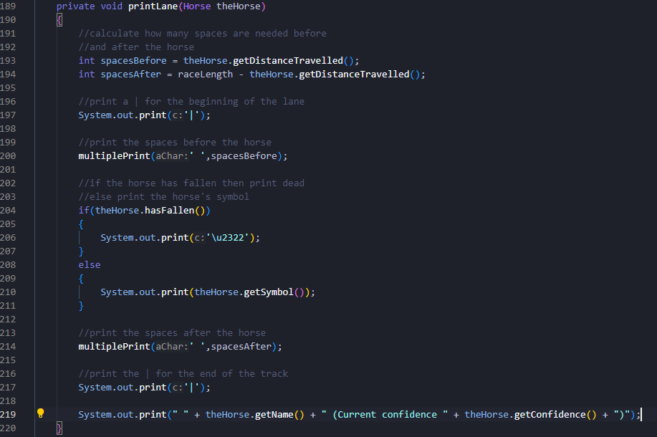

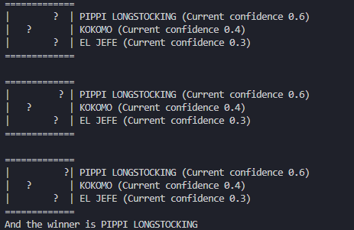

However, with this run I noticed two issues: one was that it didn’t show the updated confidence after the horse won, and the other is that it would be difficult to distinguish a fallen horse to a normal horse due to the UTF-8 encoding not working.

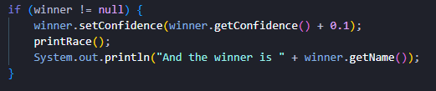

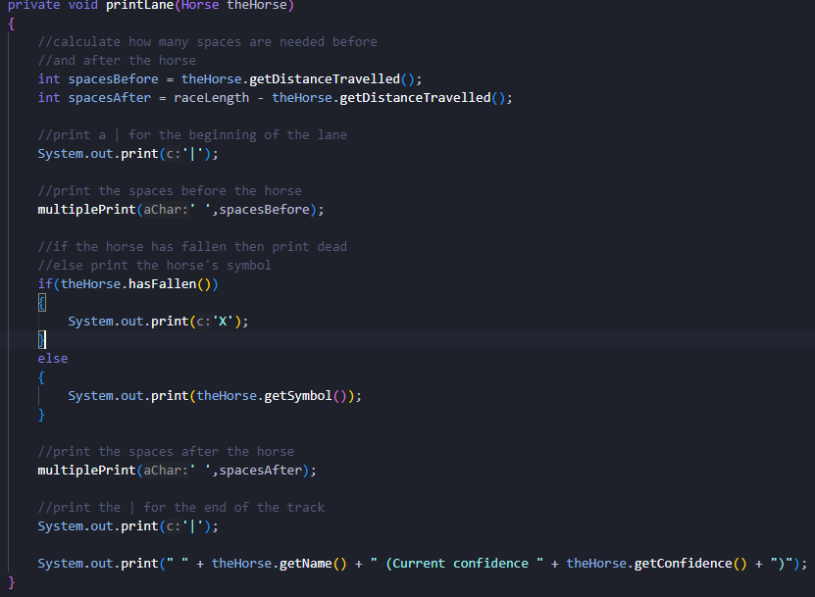

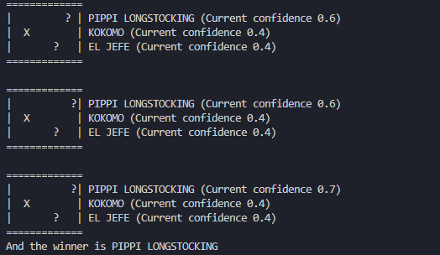

This has fixed both issues; however, this would mean that symbol X would not be able to be used as a horse icon and the last 2 run positions of the race are repeated. However, due to this fix being better than before I was satisfactory with the solution.

I also noticed on the rare occasion that all horses fall, the race wouldn’t end and the loop would continue endlessly due to no event causing finished to be true as the horses are unable to move.

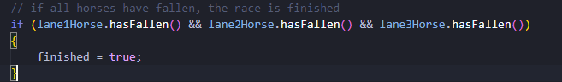

Class Race:

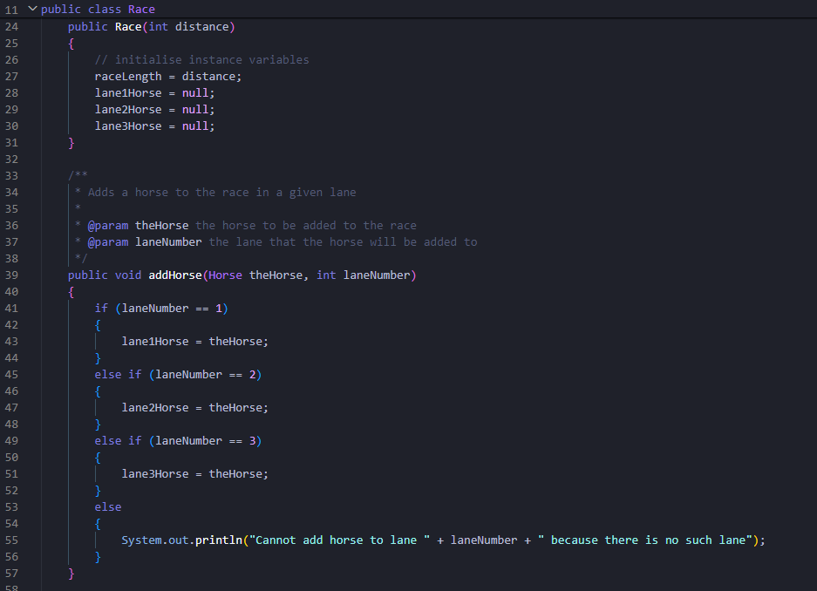

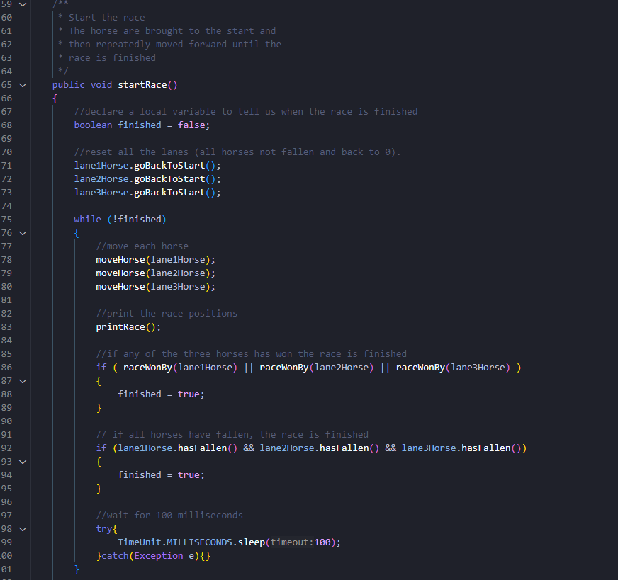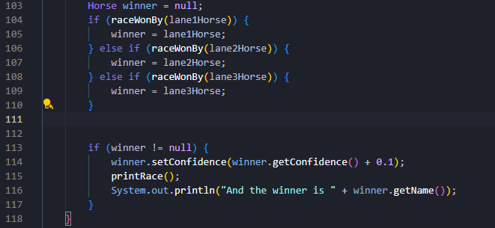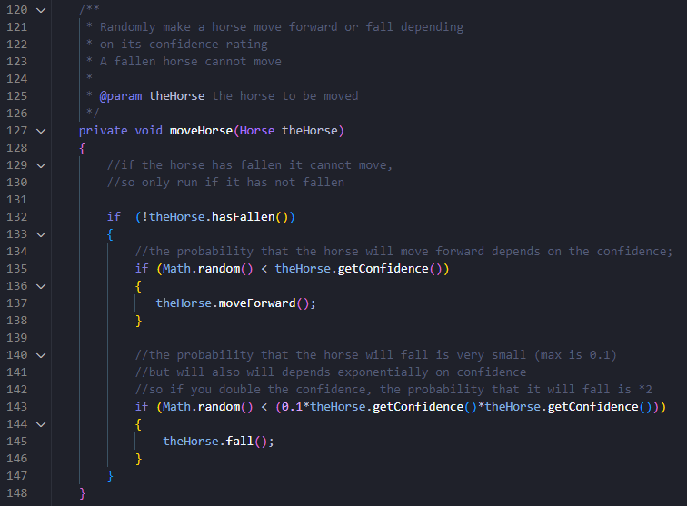

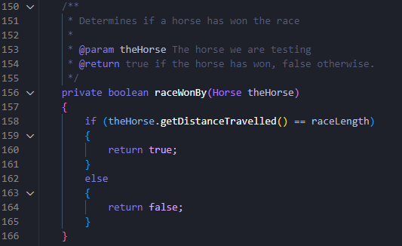

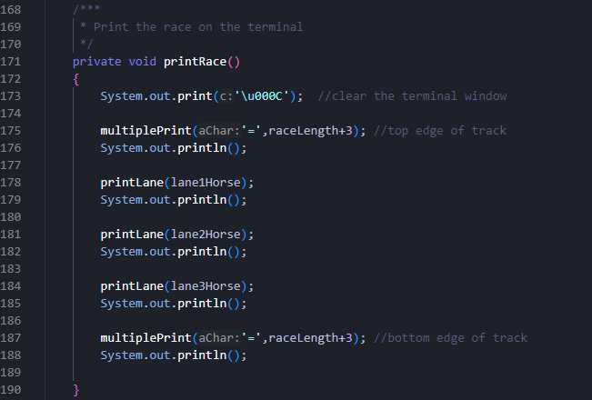

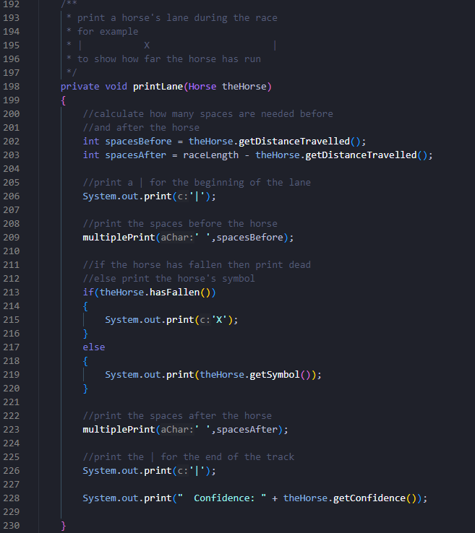

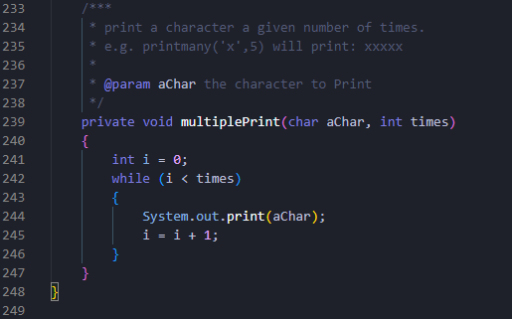

Class Horse:

